Kuberntes again

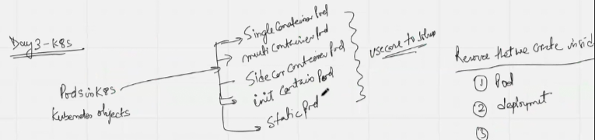

POD is the smallest resource in K8S

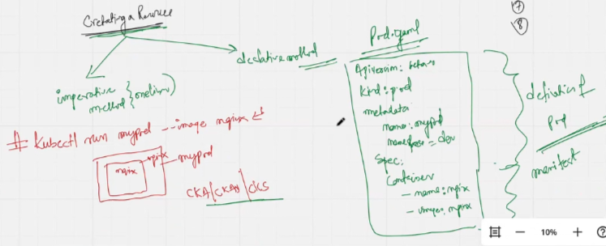

Example of declarative and imperative resource creation variation

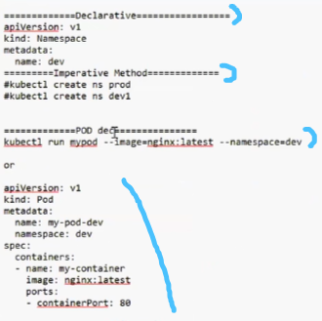

Logical and syntax config issues in this POD definition:

Multi-container POD

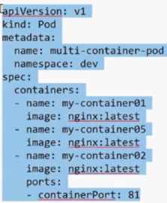 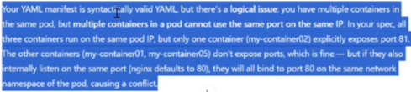

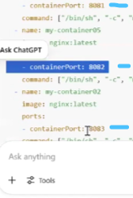 ……To resolve by exposing a port.

Side-car container POD

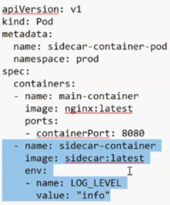

Static container POD

1. Static POD is a POD which is not managed via control-plane, means kube scheduler don’t give command to kubelet to create any static POD
2. Static POD will be created on any worker-node
3. If you delete any static POD, it will not get recreated

POD v/s deployment

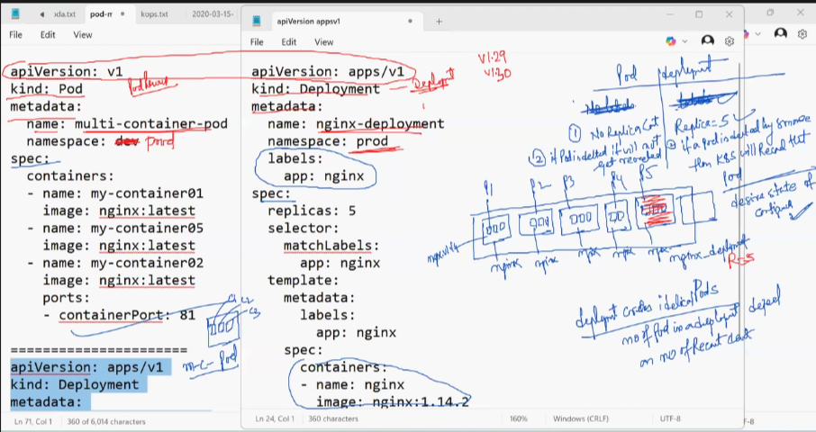

| **Replica Count** | No replica count in POD entails that single POD exists with containers | Replica=5 in Deployment entails that multiple POD exists having containers |
| --- | --- | --- |
| **Deletion criterion** | If POD is deleted, it will not get recreated | If POD deleted by someone, then K8S will recreate that POD |
| **Manages** | One or more containers directly | One or more PODs via ReplicaSets |
| **Self-healing** | No | Yes |
| **Scaling** | Manual | Automatic |
| **Updates** | None | Rolling updates and rollbacks |
| **Use case** | Single-run or simple tasks | Production workloads needs HA |

Deployment controller - It is defined as the deployment entity which creates a new POD to maintain the desired replica count if a POD in the **my-deployed** deployment is deleted

Service in K8S

A service in Kubernetes is an abstraction that defines a stable network endpoint to expose and load-balance access to a set of pods, enabling reliable communication within or outside the cluster even if PODs are replaced or rescheduled.

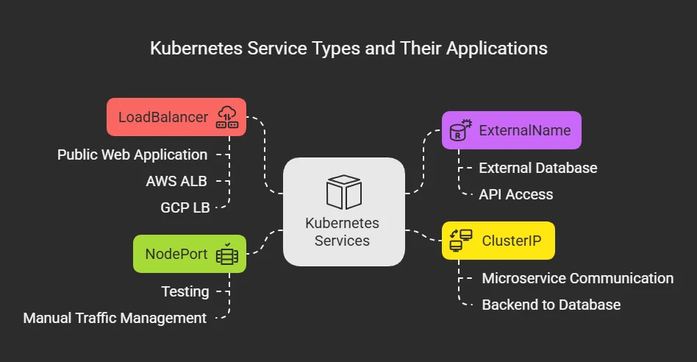

Example of 5 ingress controllers:

In K8S, the traffic flows(N-S traffic so-called) on the basis of label associated with the service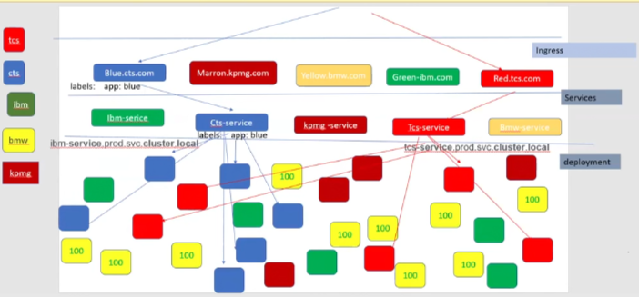

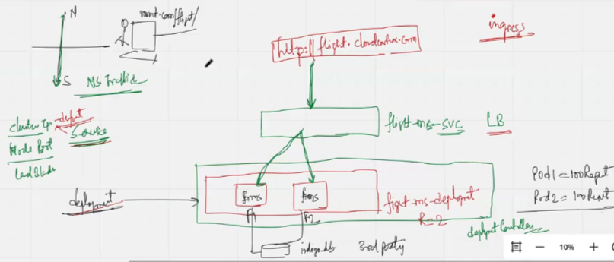

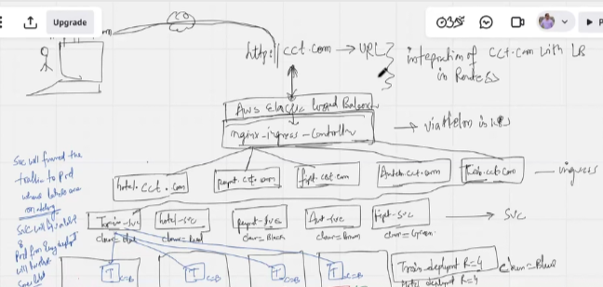

When a user ping a web-host-ip address, it reaches AWS Elastic load balancer which binds nginx-ingress-controller via Route53. Nginx-ingress-controller is deployed by K8S using Helm, while Load balancer duties on ingress controller are performed by Elastic load balancer. The ingress and service binding that distributes the traffic to separate worker-nodes mandates the installation of nginx-ingress-controller.